The University of Azad Jammu and Kashmir, Muzaffarabad


Course: DIP
Course Code: CS-2204
Roll No: 2024-SE-33
Lab: 01
Submitted To: Engr.Fahad Nisar
Submitted By: Momna imran
Date:29 oct, 2026

Image Processing Lab 01: Explanation Report

Step 1: Install and Verify Required Libraries for Image Processing Lab

1. Overview
The primary purpose of this step is to install and verify the required Python libraries for image processing. This ensures that all functions related to image manipulation, visualization, and array operations can execute smoothly without any errors throughout the lab.

2. Core Components and Explanation
- OpenCV (cv2 - opencv-python):
  - Role: The core library for computer vision and digital image processing.
  - Functionality: Used for reading images, resizing, converting color spaces (such as BGR to RGB or Grayscale), and executing basic image operations.
- Matplotlib (matplotlib.pyplot):
  - Role: Python’s standard data visualization library.
  - Functionality: OpenCV handles images in BGR format by default, while standard display requires RGB format. Matplotlib is used to properly display and plot images with correct colors on the screen.
- NumPy (numpy):
  - Role: The core library for high-performance numerical computations and multi-dimensional array manipulation.
  - Functionality: Digital images are represented in Python as 2D or 3D NumPy arrays, where pixel values are stored in the uint8 data type (ranging from intensity values of 0 to 255).

3. Implementation Logic
- Library Installation: The command !pip install opencv-python matplotlib numpy automatically downloads and installs missing packages in the Google Colab environment.
- Verification: The code imports the libraries and verifies their basic setup to ensure that subsequent image processing workflows can run smoothly.

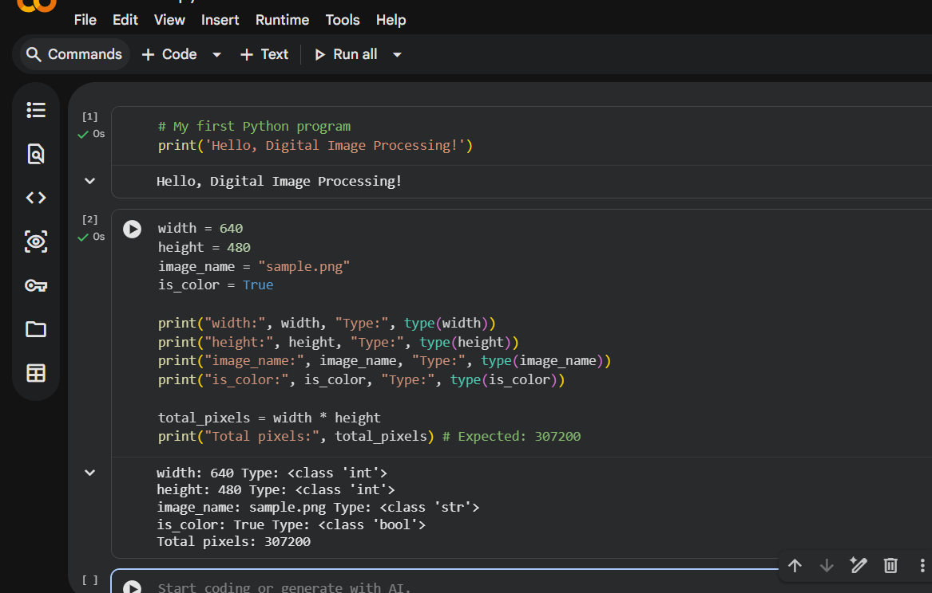

Step 2: Image Loading and Metadata Inspection

1. Overview
The primary objective of this step is to automatically search for image files (.jpg, .jpeg, .png) within the current working directory or the /content/ folder, load the first available image, and inspect and print its basic metadata (such as dimensions and data type).

2. Core Components and Explanation
- Directory Scanning (glob and os modules):
  - Role: Used to dynamically search for file paths.
  - Functionality: The code defines extensions = ['*.jpg', '*.jpeg', '*.png'] and uses glob.glob() to scan the environment for available images. If no image is found, it raises a FileNotFoundError so the user knows to upload an image first.
- Image Loading (cv2.imread):
  - Role: Loads the image file into memory as a matrix or array.
  - Functionality: OpenCV reads images in the BGR (Blue, Green, Red) color format by default, which differs from the standard RGB format.
- Metadata Extraction (shape and dtype):
  - Dimensions (img_bgr.shape): Provides information regarding the image's height, width, and number of channels (e.g., an output like (148, 212, 3) means a height of 148 pixels, a width of 212 pixels, and 3 color channels).
  - Data Type (img_bgr.dtype): Indicates the data type in which pixel values are stored (typically uint8, representing intensity values ranging from 0 to 255).

3. Implementation Logic
- The program automatically checks the file system, loads the image into memory, and prints its array attributes to confirm that the image has loaded successfully and is ready for further processing.

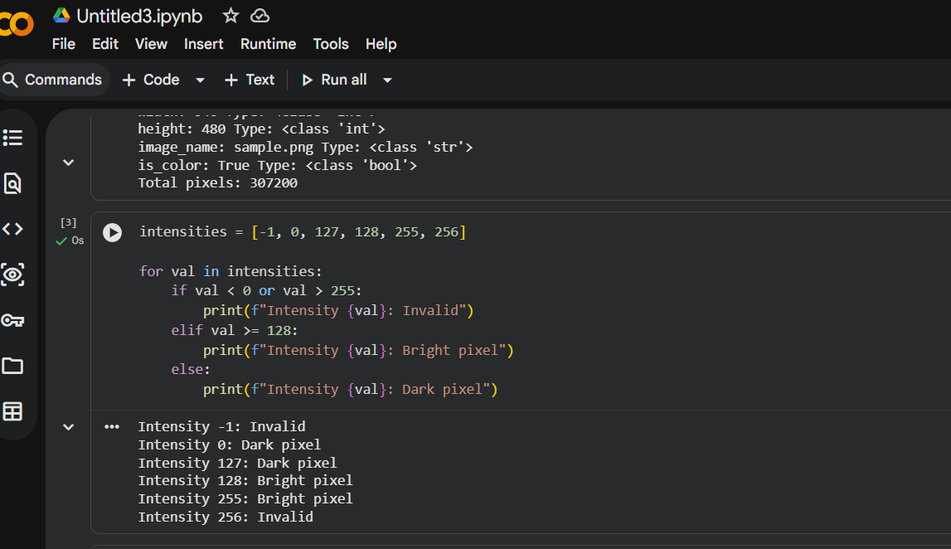

Step 3: Image Inspection & Pixel-Level Analysis

1. Overview
The primary objective of this step is to further inspect the loaded image by analyzing its structural dimensions explicitly and accessing specific pixel values (such as top-left or center coordinates) to understand intensity levels at a granular level.

2. Core Components and Explanation
- Structural Dimension Extraction:
  - Role: Isolating individual properties from the image's shape attribute.
  - Functionality: Using height, width, channels = img_bgr.shape, the code separates and explicitly prints the total height, width, and depth (color channels) of the image array for structured documentation.
- Pixel-Level Value Access:
  - Role: Reading exact numerical intensity values from specific coordinate matrices.
  - Functionality: Digital images are treated as multi-dimensional matrices. Accessing a specific coordinate (e.g., img_bgr[y, x]) retrieves an array of values representing intensity levels for the Blue, Green, and Red channels respectively.
- Intensity Analysis:
  - Role: Evaluating raw pixel data.
  - Functionality: Helps inspect individual color channel intensities ranging from 0 to 255, which forms the foundation for subsequent pixel transformations, thresholding, and filtering tasks.

3. Implementation Logic
- The program extracts spatial metrics from the array shape and queries precise coordinate indexes to demonstrate how raw pixel data can be directly read, printed, and analyzed from memory.

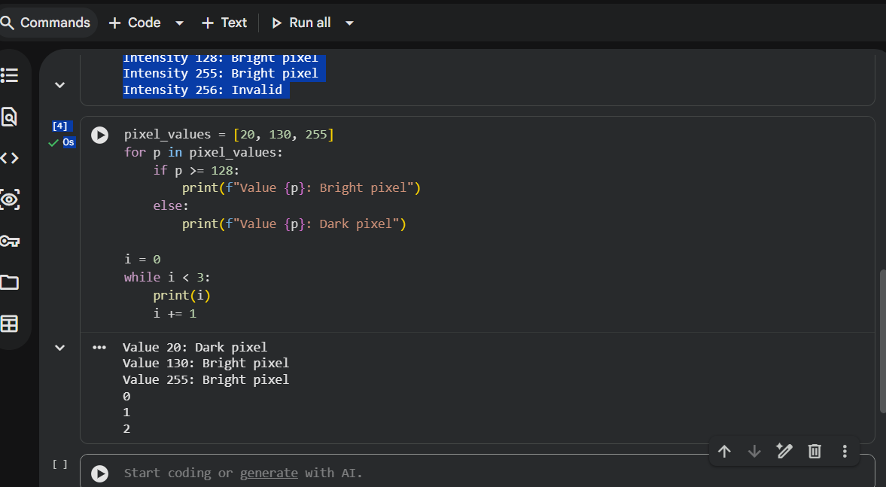

Step 4: Color Space Conversion and Channel Separation

1. Overview
This step focuses on transforming the image into different color spaces—converting from OpenCV's default BGR format to standard RGB for correct visualization, converting to Grayscale for simplified processing—and splitting the image into its individual constituent color channels.

2. Core Components and Explanation
- Color Space Conversions (cv2.cvtColor):
  - BGR to RGB (cv2.COLOR_BGR2RGB): OpenCV loads images in BGR format by default. Since standard plotting libraries like Matplotlib expect RGB, this conversion swaps the channels to ensure correct color representation during visualization.
  - BGR to Grayscale (cv2.COLOR_BGR2GRAY): Converts a 3-channel color image into a single-channel intensity image. This is vital because many image processing operations (such as edge detection, thresholding, and contour extraction) require single-channel inputs to minimize computational complexity.
- Channel Splitting (cv2.split):
  - Role: Dissecting a multi-channel image into its independent component planes.
  - Functionality: The cv2.split() function separates the BGR image into individual Red, Green, and Blue channel arrays, allowing you to examine how each color contributes independently to the overall image composition.
- Visualization:
  - Role: Plotting processed versions side-by-side.
  - Functionality: Uses Matplotlib to display the converted RGB image, grayscale version, and individual split channels concurrently for visual comparison.

3. Implementation Logic
- The program applies transformation functions to alter the color structure of the base image, splits the color channels into separate matrices, and plots them alongside the grayscale output to analyze color distribution.

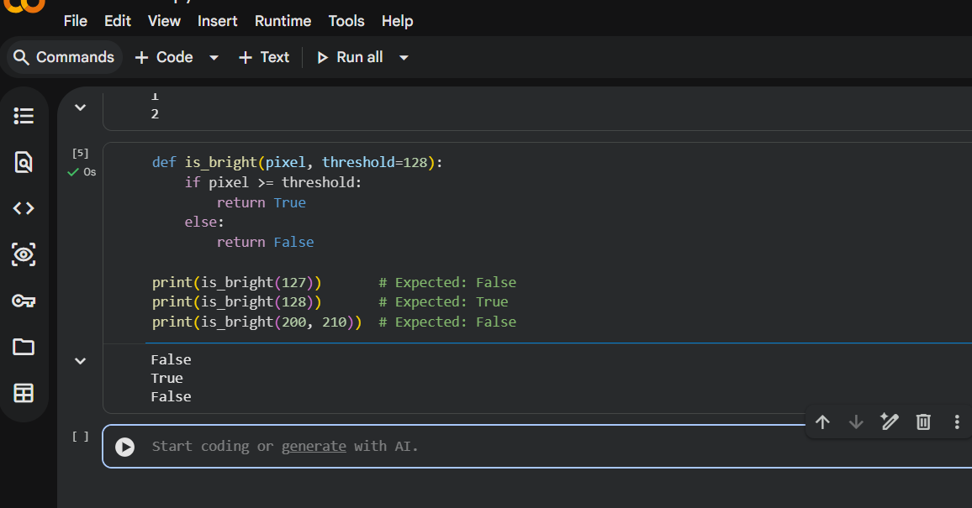

Step 5: Image Cropping and Resizing

1. Overview
The primary objective of this step is to perform spatial manipulation on the image by cropping a specific region of interest (ROI) using array slicing and adjusting its dimensions using resizing functions, followed by saving the processed output.

2. Core Components and Explanation
- Image Cropping (NumPy Array Slicing):
  - Role: Extracting a localized sub-region from the larger image matrix.
  - Functionality: Because digital images are represented as multi-dimensional NumPy arrays, cropping is executed by slicing row and column index ranges (e.g., cropped_img = img[startY:endY, startX:endX]). This isolates a precise area of interest for targeted analysis.
- Image Resizing (cv2.resize):
  - Role: Altering the spatial dimensions (width and height) of the image array.
  - Functionality: The cv2.resize() function scales the cropped section or full image to custom target pixel dimensions. This is crucial for standardizing image inputs across a dataset or pipeline.
- Saving Processed Output (cv2.imwrite):
  - Role: Exporting and persisting modified image data to the environment storage.
  - Functionality: The cv2.imwrite() function takes the processed image matrix and writes it back to disk as a standard image file (e.g., .png or .jpg) for reporting or further use.

3. Implementation Logic
- The program slices the image array to isolate a specific window, applies a scaling transformation to modify its physical dimensions, and writes the final output to the working directory.

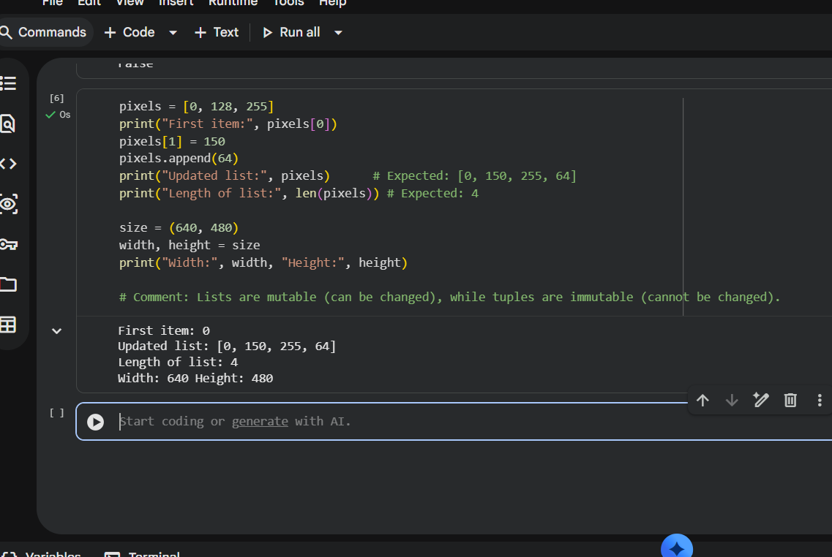

Step 6: Targeted Resizing, Histogram Generation, and Bit-Depth Analysis

1. Overview
The final step of the lab focuses on standardizing image dimensions using targeted resizing, analyzing pixel intensity distributions through histograms, and exploring how reducing bit-depth (quantization) impacts overall image quality and visual fidelity.

2. Core Components and Explanation
- Targeted Resizing (cv2.resize):
  - Role: Scaling images to uniform, predefined dimensions.
  - Functionality: When preparing image datasets for computer vision models, uniform dimensions are required. This step uses explicit target widths and heights (e.g., standardizing to specific pixel dimensions) via OpenCV's cv2.resize() function to ensure consistency across all input samples.
- Histogram Generation (cv2.calcHist):
  - Role: Visualizing pixel intensity distributions across an image.
  - Functionality: A grayscale histogram maps the frequency of each pixel intensity value (ranging from 0 for pure black to 255 for pure white). Using cv2.calcHist() alongside Matplotlib, the code plots this distribution to help evaluate the overall brightness, contrast, and dynamic range of the image.
- Bit-Depth Quantization:
  - Role: Analyzing the effects of reducing color or intensity levels.
  - Functionality: Standard digital images use 8-bit depth, providing 256 distinct intensity levels. This part of the lab demonstrates quantization by reducing an 8-bit image to lower bit-depths (such as 4-bit, 2-bit, or 1-bit binary), visually showing how decreasing intensity levels introduces false contouring and reduces image fidelity.

3. Implementation Logic
- The program resizes the image to target dimensions, calculates and plots its intensity histogram, and applies bit-depth quantization transformations to generate comparative visual outputs for comprehensive lab reporting.

